Contents

Introduction 2

Task 1 2

Windows Installation 2

Installation of Windows 2

Identification of key stages in installation 2

Identification and description of required device drivers and their source location 10

Monitor: 10

Sound Card: 11

Identification of unresolved issues 11

Installation of Antivirus Software 12

Identification of product used 12

Identification of key stages in installation 12

Outline of the update process for the antivirus software 14

Identification of unresolved issues 15

Installation of Office Software 16

Identification of product used 16

Identification of key stages in installation 16

Identification of unresolved issues 19

Installation of free utility 20

Identification of the utility 20

Identification of key stages in installation 20

21

Identification of Unresolved Issue 21

Task 2- Linux Installation 22

Installation of Linux 22

Identification of distribution 22

Description of Disk Partitioning 22

Identification of required device drivers and their source locations 23

Description of setting up administrator and standard user 27

Description of Network Set-Up 29

Identification and Installation process for one application 30

Testing of Linux System 32

Identification of test plan for system 32

Record of how system performs against test plan 32

Task 3 35

Faulty PCs 35

The Screen is Blank: 35

PC Overheating 35

PC crash before loading the OS 36

Wi-Fi not working 36

Hard drive missing 36

FIGURES

Figure 1: Selecting Language, keyboard and time format 5

Figure 2 : Accepting license terms 6

Figure 3: Installation type 7

Figure 4: Partition Table 8

Figure 5: windows installing 9

Figure 6: Creating Account 10

Figure 7: Windows 10 pro 11

Figure 8: Monitor driver 12

Figure 9: Sound Card Driver 13

Figure 10: Installing COMODO Antivirus 15

Figure 11: COMODO Antivirus Installed 16

Figure 12: Updating Process 17

Figure 13: Installation begins 19

Figure 14: Accepting term and condition 20

Figure 15: Installation Completed 21

Figure 16: Successfully installed Linux 23

Figure 17: Disk Partitioning 25

Figure 18: lspci command 26

Figure 19: lsmod command 27

Figure 20: modinfo soundcore 28

Figure 21: modinfo Video 29

Figure 22: Administrator User 30

Figure 23: Standard Users 31

Figure 24: Network Set-up 32

Figure 25: VLC Installed 33

Figure 26: Main Areas of Testing 34

Figure 27: Test Plan Performed 36

# Introduction

A well-managed document accessed by Portfolio of work is maintained and developed, through which it helps to recognize the skills and abilities and also reflects our laboratory performance. Oracle Virtual Box is an operating system (OS) or application environment that is installed on software, which basically provides a virtual operating system environment in another Operating system of Computer. I have used virtual box to complete my assignment.

# Task 1

# Windows Installation

I have chosen Oracle virtual box for the installation of windows 10 pro. Windows 10 pro OS is the product of Microsoft which is an upgrade version for Windows 10 operating system.

## Installation of Windows

## Identification of key stages in installation

In the beginning phase, I have selected windows 10 pro of 64 bits version on my virtual machine. After that appropriate ISO file was chosen from local disk for installation process. Finally the installation process starts with choosing language, Input method and time format where I have chosen English (US) as shown in figure below. 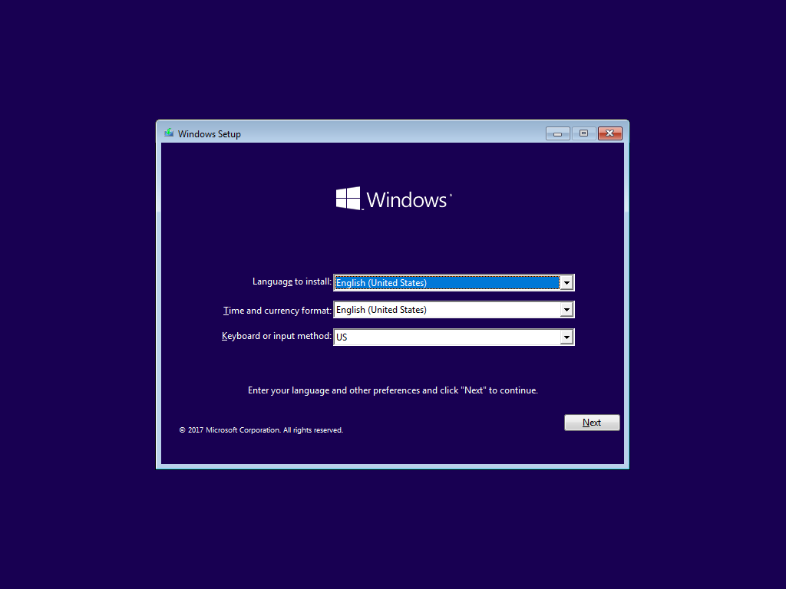

Figure : Selecting Language, keyboard and time format

Likewise, windows setup is started by selecting windows 10 pro operating system for my pc windows on the virtual machine. I have accepted the license term and conditions which is the mandatory phase on installation process as shown in figure below.

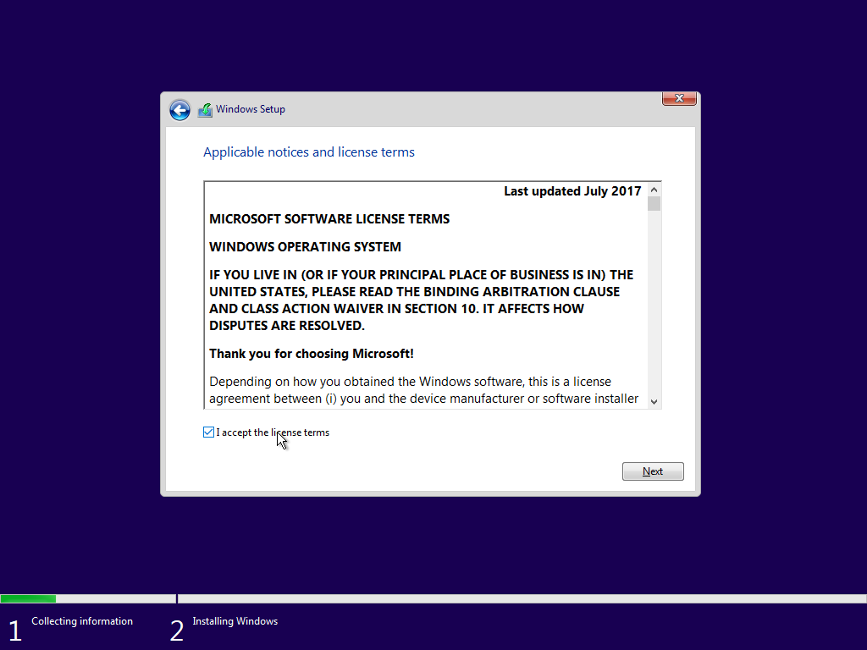

Figure : Accepting license terms

Likewise, Instead of choosing Upgrade Installation I have an option to choose the custom type. In custom type installation we can do disk partition where upgrade installation only upgrade the OS as required but its lack of upgrade process because this process is used to upgrade the OS of the computer used.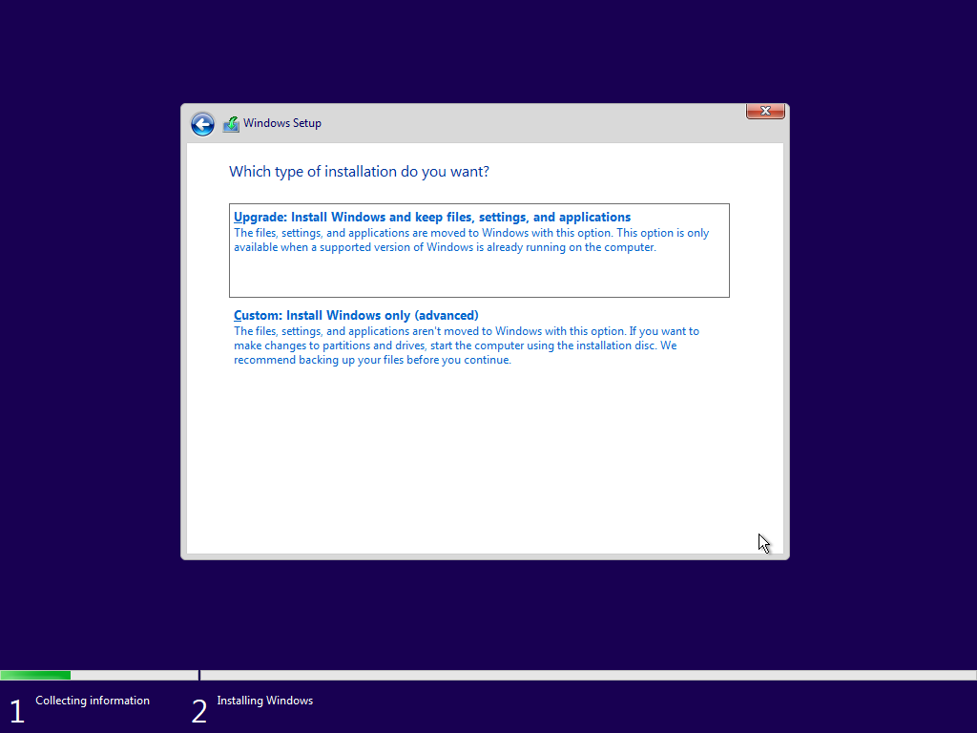

Figure : Installation type

Additionally, Disk partition appeared, I have given 200GB Memory space on the hard drive from Oracle Virtual Machine. I did the primary partition and booting process is started on primary storage as shown in figure 4.

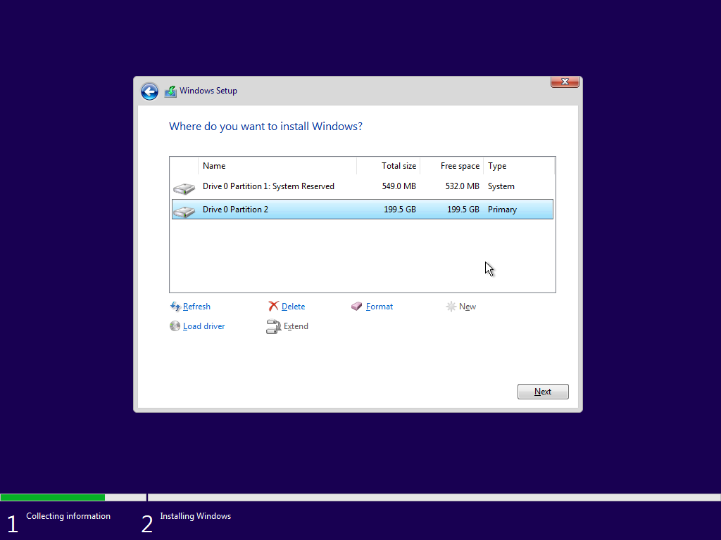

Figure : Partition Table

Furthermore, installation process starts out by copying windows files, installing features and installing updates which take several minutes to finish up the installation process and during installation of windows users may face several times restarting computer system.

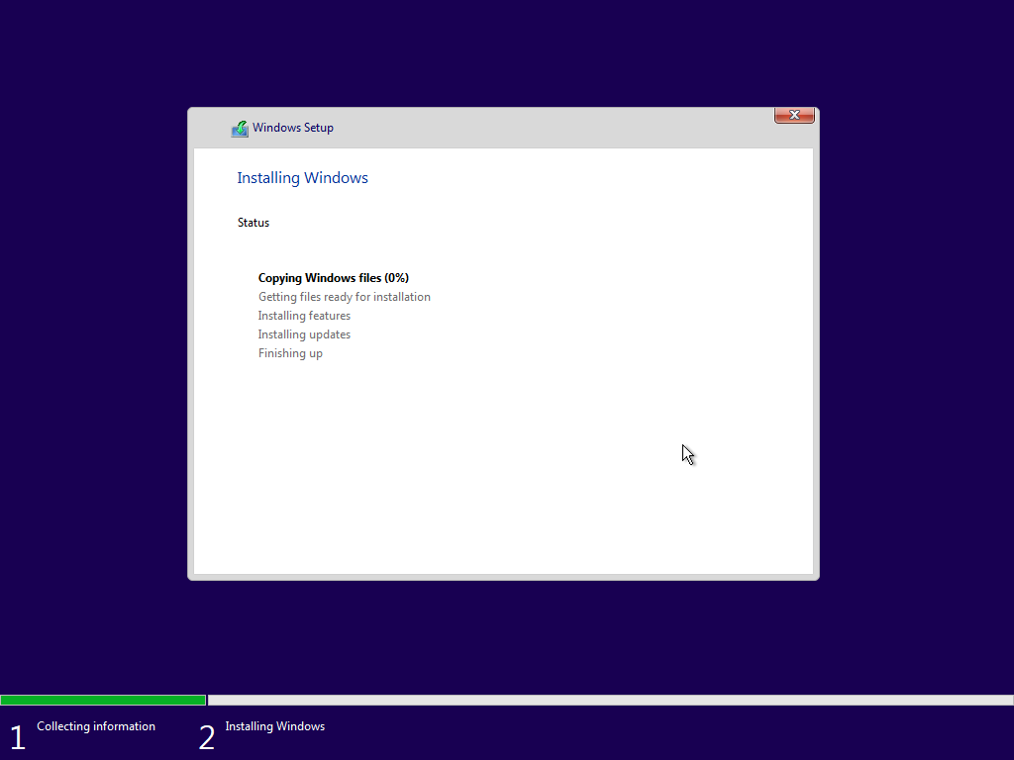

Figure : windows installing

Going through the stepwise process, Final setup was giving a name of the person or PC name on who's going to use this pc where I have set up account by simply typing my Name and used a strong and memorable password where I have added the hint which may help for its recovery.

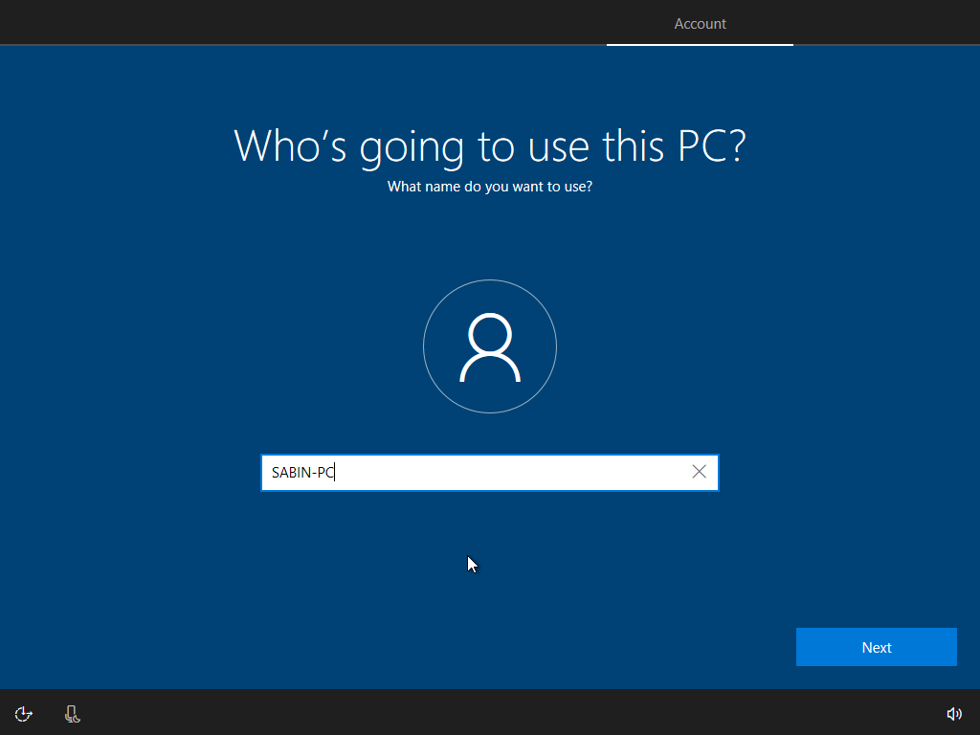

Figure : Creating Account

Finally, windows 10 pro installation process is completed.

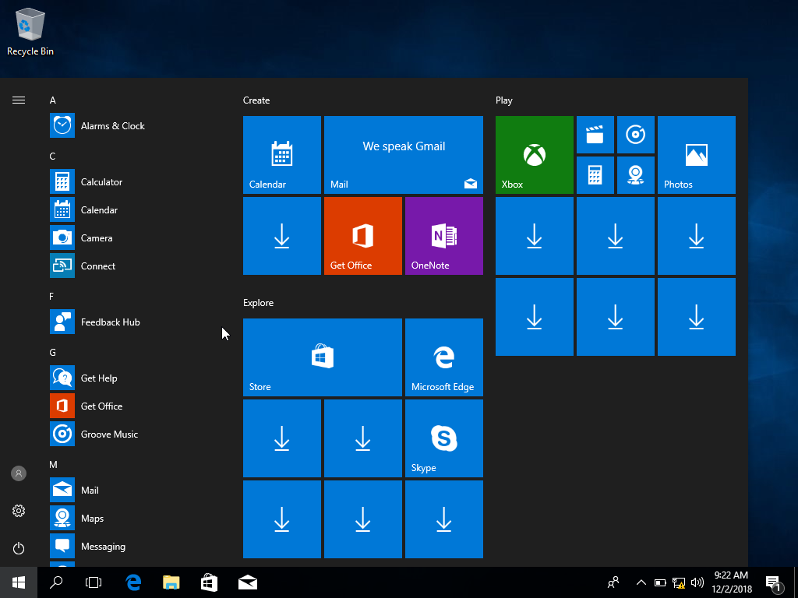

Figure : Windows 10 pro

## Identification and description of required device drivers and their source location

Device manager reflects a central and organized view of all the Microsoft Windows recognized hardware components setup in a computer. It can be used for changing hardware configuration options and also for enabling and disabling drivers and much more. Without a device manager computer lack some important functions to process.

Some of the device drivers are shortly details below:

**Monitor:**

Monitor provides information to the user when task is given to the computer to perform. Video card helps to converts binary’s 1s and 0s into images and display on monitor.

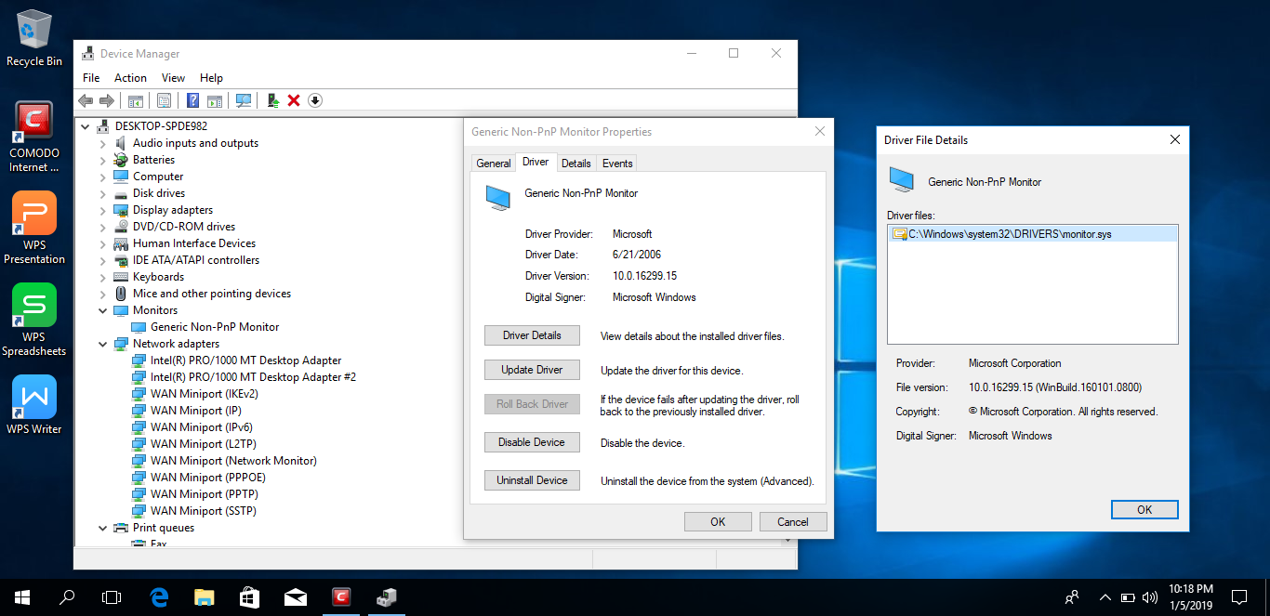

Figure : Monitor driver

**Sound Card:**

Sound card converts incoming digital audio into analogue audio so that the connect speaker can play it. 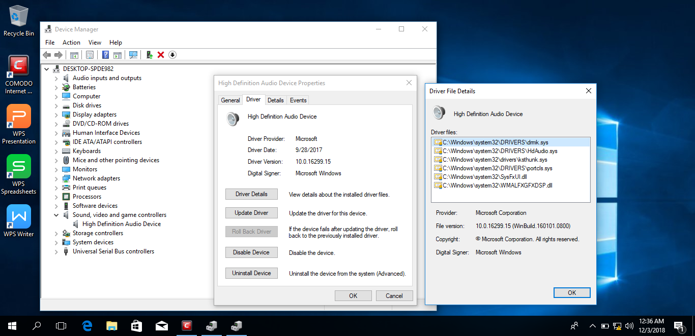

Figure : Sound Card Driver

## Identification of unresolved issues

Here on my Windows 10 pro, I haven’t faced any unresolved issues after the installation process. Device manager might face some issues.

* If driver missing from pc
* If device driver is out of date

# Installation of Antivirus Software

## Identification of product used

Comodo antivirus is a free utility application which uses more security layers to protect our computer from different viruses, Trojan horse and so on. Some function of comodo antivirus software are listed below:

* It has the ability to identify malware-virus, worms, Trojans, and so on
* It quickly deletes the malware from pc
* It has the capacity of scanning files download from internet sources.
* It provides cloud-based scanning facilities for efficient performance.

Before installation of Comodo Antivirus, I have downloaded a free Comodo antivirus from the online source and after completing the download process, the installation of Comodo antivirus is startup.

Here on my Windows 10 pro, I haven’t face any unresolved issues but during installation due to low RAM on my pc installation process was very slow. I researched all drivers were fine.

## Identification of key stages in installation

Before clicking on install bottom, comodo antivirus makes us to choice installation directory for installation of antivirus. After that make sure you have accepted terms and conditions of antivirus then start the installation process as shown in figure 10. It doesn’t consume much time to install.

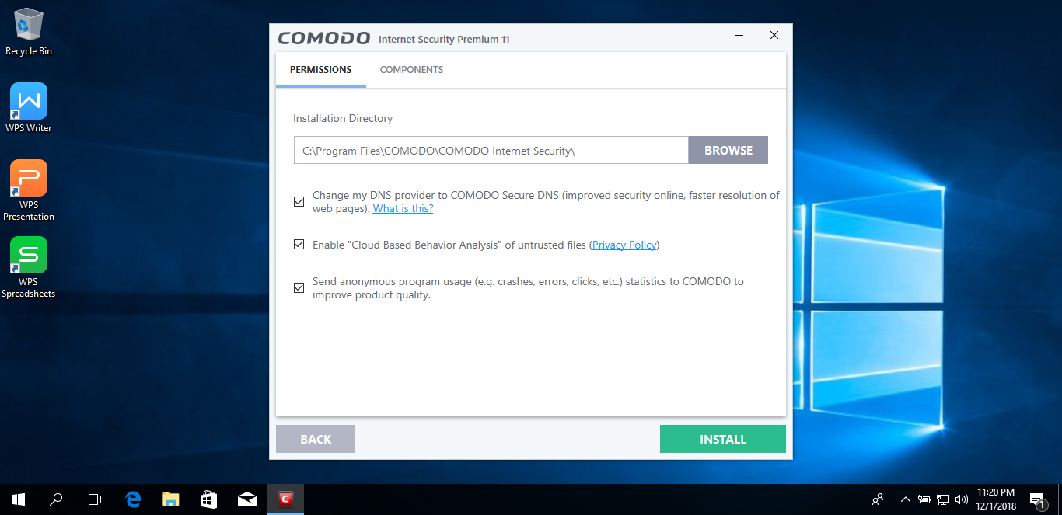

Figure : Installing COMODO Antivirus

After the installation process as shown in figure 11, comodo antivirus asked us to perform an initial scan to fix the protection for unwanted viruses. It takes around 3 to 4 minutes to complete quick scan.

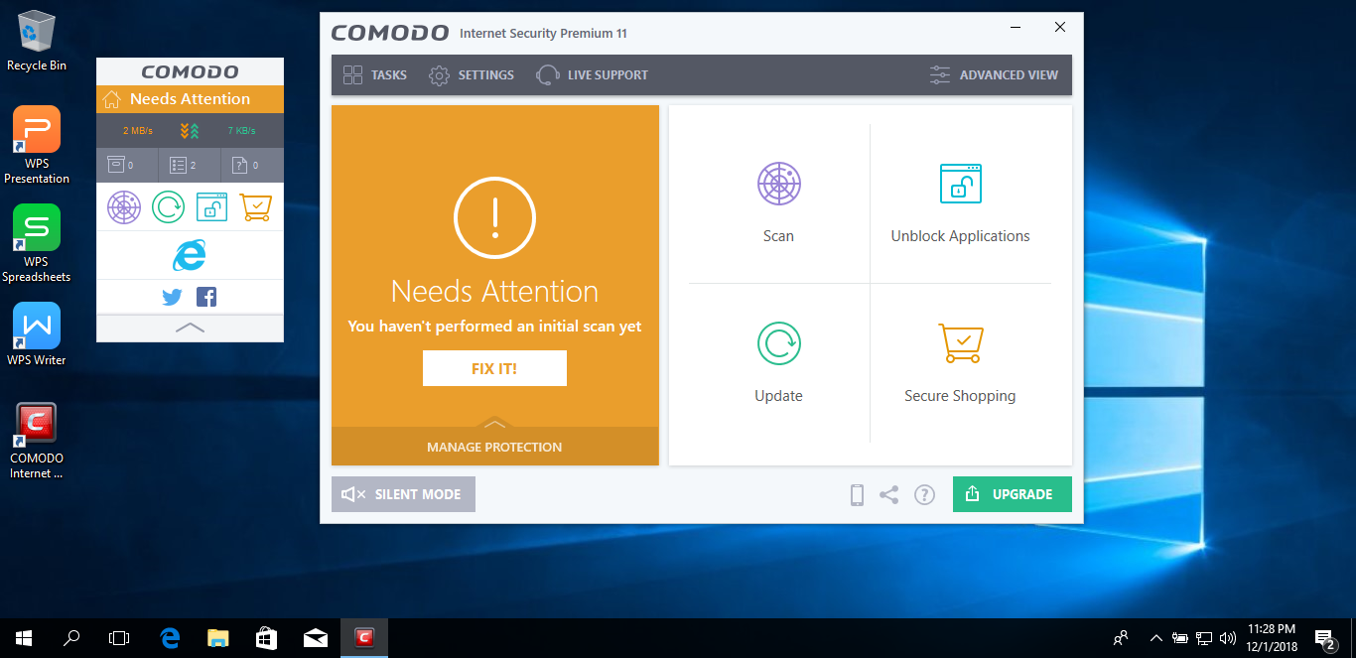

Figure : COMODO Antivirus Installed

## Outline of the update process for the antivirus software

We can update antivirus manually or automatically according to user’s choice. During Updating process, comodo antivirus automatically checks for and download database and program updates. To complete the update process system asks to restart the pc.

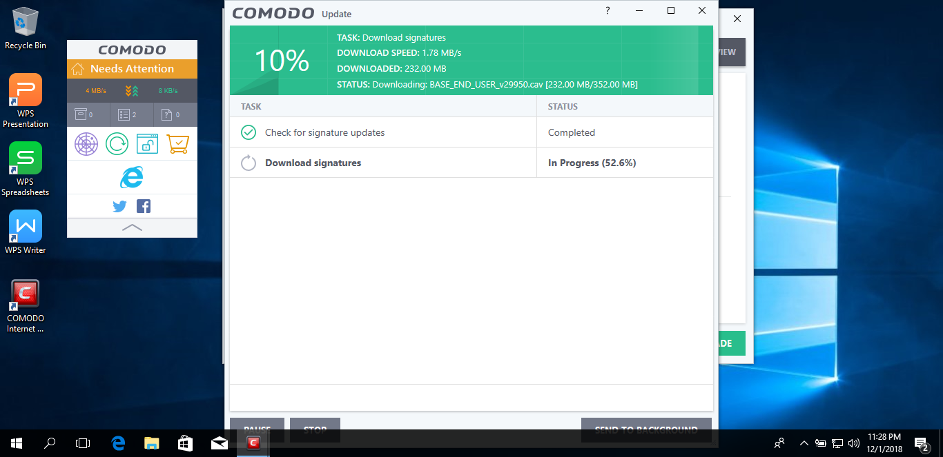

Figure : Updating Process

## Identification of unresolved issues

There was already installed 360 total security antivirus on my computer. When I try to install comodo antivirus software on my pc, the system asks to uninstall 360 total security from the computer system. I had disabled 360 total security from pc and install comodo antivirus successfully. After that I have not face any problems on antivirus for the protection of pc.

# Installation of Office Software

## Identification of product used

WPS Office 2016 is free for windows to use. It is very efficient, highly compatible, and cross-platform office suite which can be used for personally or in office or for educational purposes and so on. It allows users to create documents faster, produce amazing presentation, also helps to convert PDF file to Microsoft Word documents formats and many more. Some of the features of WPS office 2016 are listed below:

* It has Customizable interface
* It is Excellent in Office compatibility
* It provides integrated cloud-based storage

## Identification of key stages in installation

Before clicking on install bottom, WPS office makes us to choice installation directory for installation. After that make sure you have accepted terms and conditions of WPS office then start the installation process as shown in figure 16. WPS Office 2016 describe about privacy policy of office. It doesn’t take much time to install.

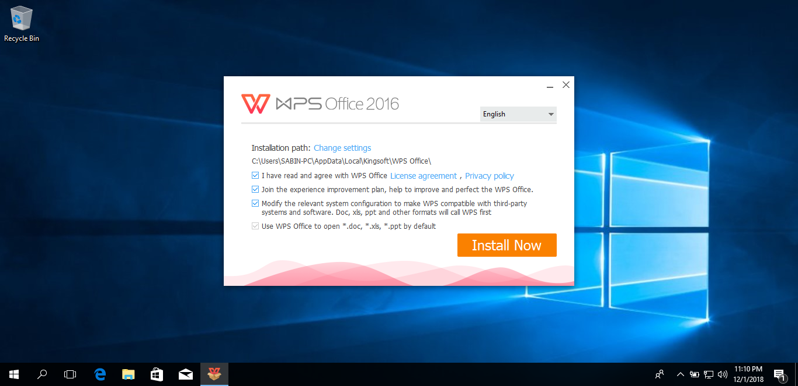

Figure : Installation begins

Likewise, after accepting terms and conditions of WPS office, the installation process was continue as shown in figure 14.

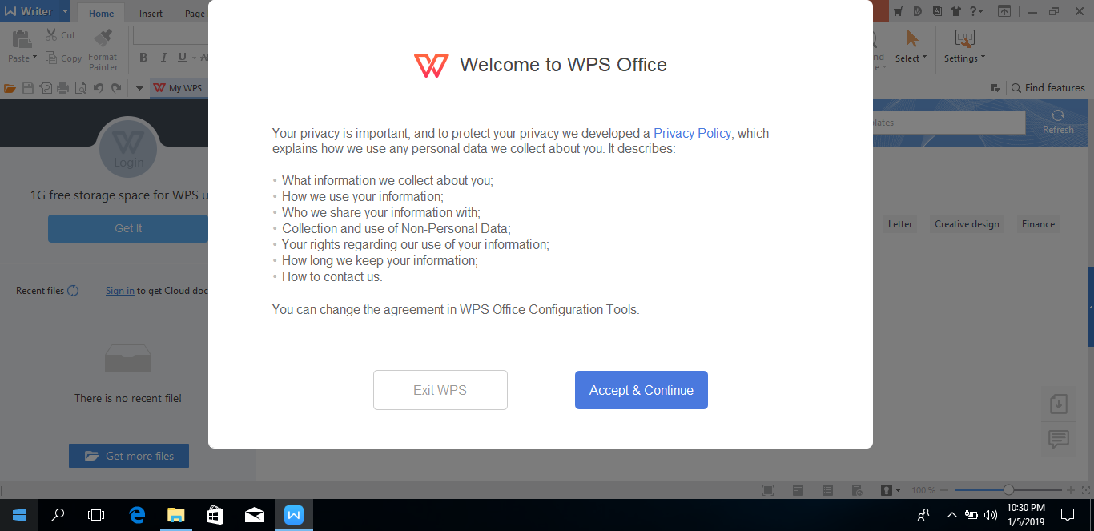

Figure : Accepting term and condition

Finally WPS Office 2016 was successfully installed on my pc as shown on figure 15.

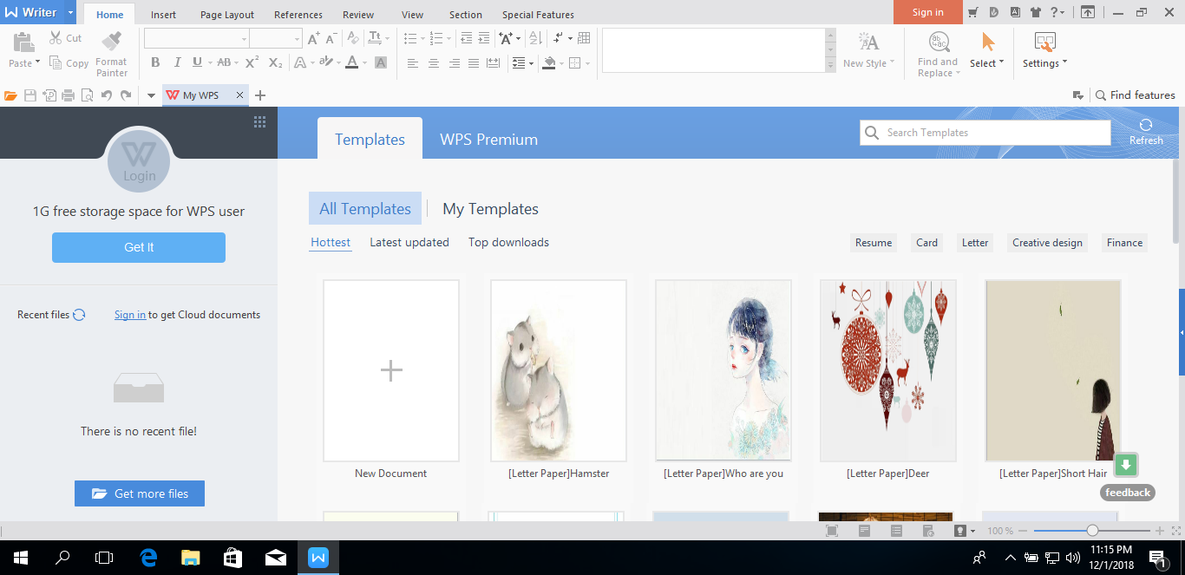

Figure : Installation Completed

## Identification of unresolved issues

I haven’t faced any unresolved issues after the installation process of antivirus. Some issues might occur when antivirus packages are lacking or another antivirus software is installed on pc.

# Installation of free utility

## Identification of the utility

Rufus is a free utility software packages for Microsoft Windows, used to format and create bootable USB flash drive or Live USB which is developed by Pete Batard of Akeo Consulting. This software is written in c programming language which available in 39 languages. Some important features of Rufus are listed below:

* It has capacity to burns any Windows ISO and Linux ISO
* Open source
* UEFI and legacy booting are handles
* It simple to use

## Identification of key stages in installation

Rufus is small utility self-executable file, so we can directly setup without customization process. Finally, the installation of RUFUS has been installed successfully on my pc as shown in figure 16.

### 

Figure : Successfully installed Linux

## Identification of Unresolved Issue

I haven’t faced any unresolved issues after the installation process. Some issues might occur.

* Fails to write an ISO containing large files
* Not opening downloaded ISO file.

# Task 2- Linux Installation

In 1991 by Linus Torvalds developed an operating system named as LINUX, which is a free open source operating system based on UNIX.

## Installation of Linux

## Identification of distribution

For the installation of Linux as per my assignment, I have Pinguy Linux OS that is built on the Ubuntu supported structure which is released in 2010 AD. Pinguy OS is looking good, very simple to use and much designed for people who are entering newly into Linux OS. This operating system is made for both Windows and MAC with many familiar features. Due to some reasons, I have chosen Pinguy OS.

* It has installation GUI
* GNOME 3 Default Desktop
* It has low system requirements
* It is Multilingual
* Many updated features are mentioned in it

## Description of Disk Partitioning

Disk Partitioning is also called disk slicing which divides a hard drive into several partitions. Partitions are created mostly when the hard drive is first being prepared to use. During the installation process, it plays a great role in running an operating system. As I have allocated 200GB memory shape for installation of Pinguy Linux and I have managed 200GB per needs of drivers in my Pinguy Linux which are listed below.

* I have given 75 GB for /home directory for storing user data and preferences.
* I have given 1 GB for /boot directory, which contains kernel and functions that the BIOS offers as services for disk access.
* I have given 10 GB for /tmp, where temporary files or directories are preserved between systems reboots.
* I have given 22 GB for /var that includes data which is changed when the system is running normally.
* I have given 10 GB for swap directory, which is the space for virtual memory when the amount of physical memory is full.
* I have given 15 GB for usr directory, which consists of several subdirectories that contain additional UNIX commands and data files. This drive is formatted as ext4 type.
* I have given the unused space for root where the primary repository of user’s files is mounted.

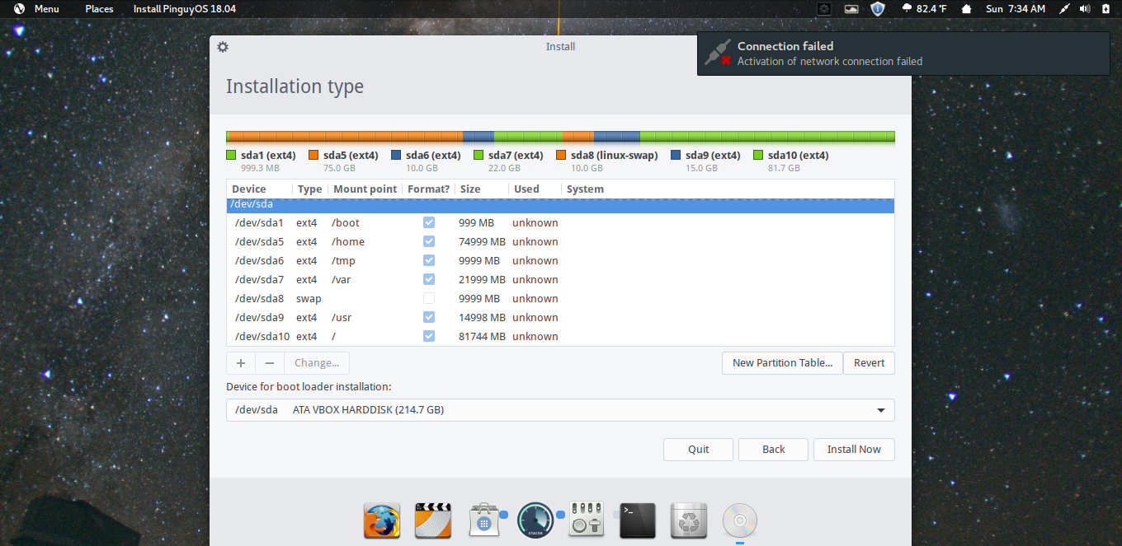

Figure : Disk Partitioning

## Identification of required device drivers and their source locations

After finishing the installation process, I have used command line interface (CLI) by pressing ctrl + alt + t from a keyboard to see driver and their exact location on my pc as shown below.

**lspci:** lspci command is used for displaying information about PCI buses in the system and device connected to them as given below.

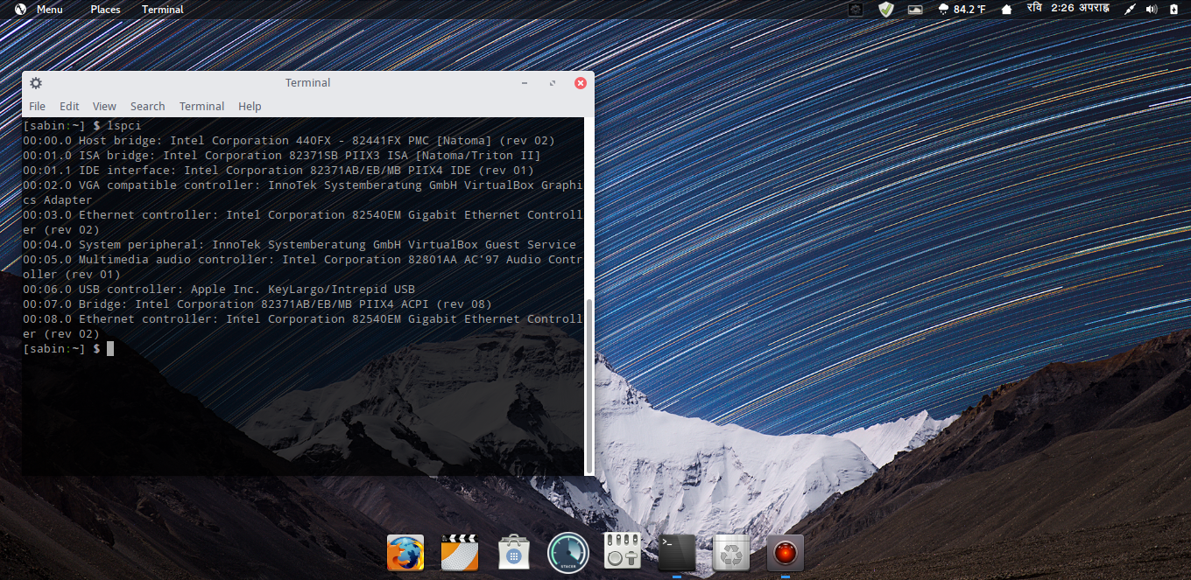

Figure : lspci command

**lsmod:** lsmod is the command which shows loadable kernel modules are currently loaded as given below.

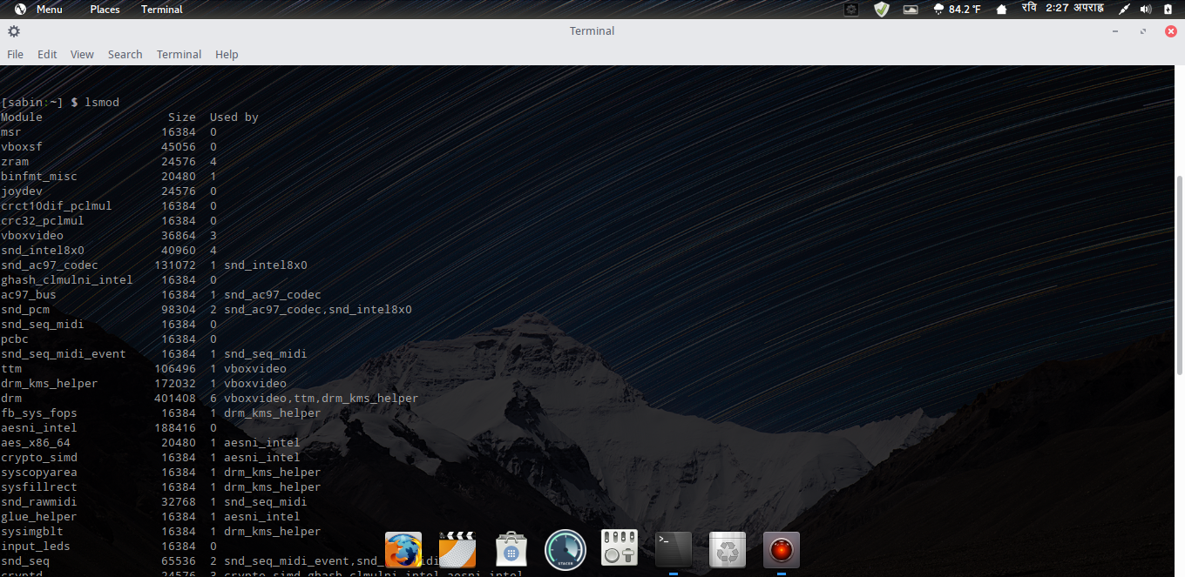

Figure : lsmod command

**Modinfo:** modinfo extracts information from the Linux Kernel modules given on the command line.

Mention figure below reflects identification and location of soundcore. 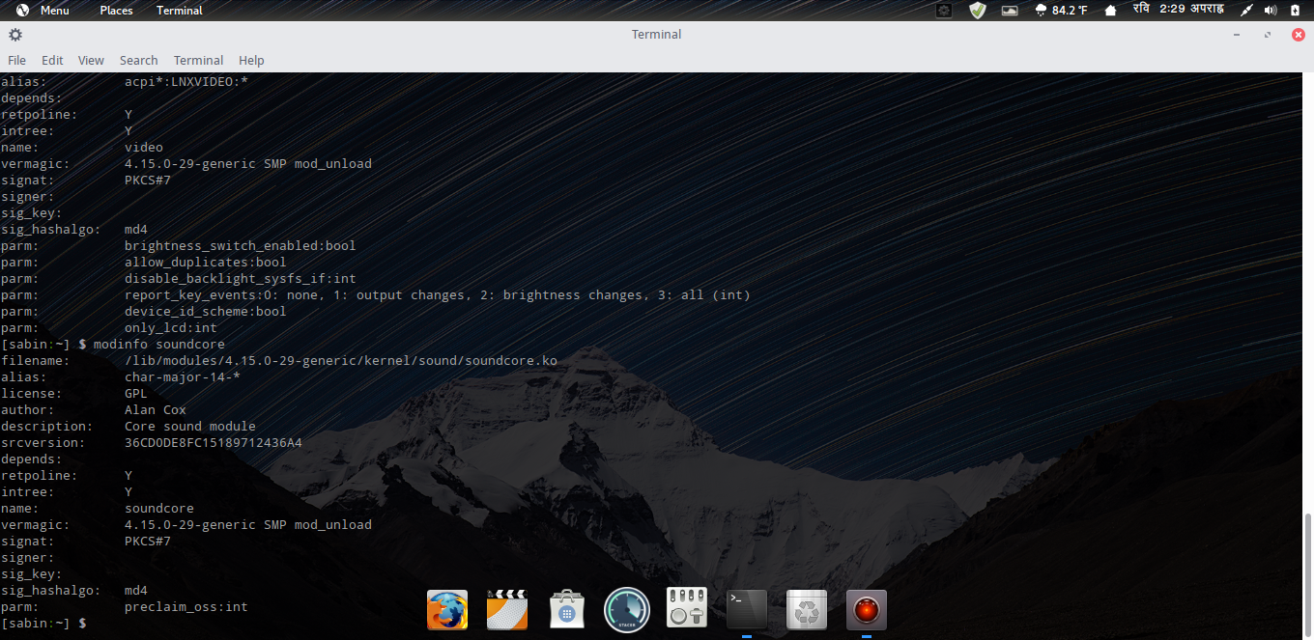

Figure : modinfo soundcore

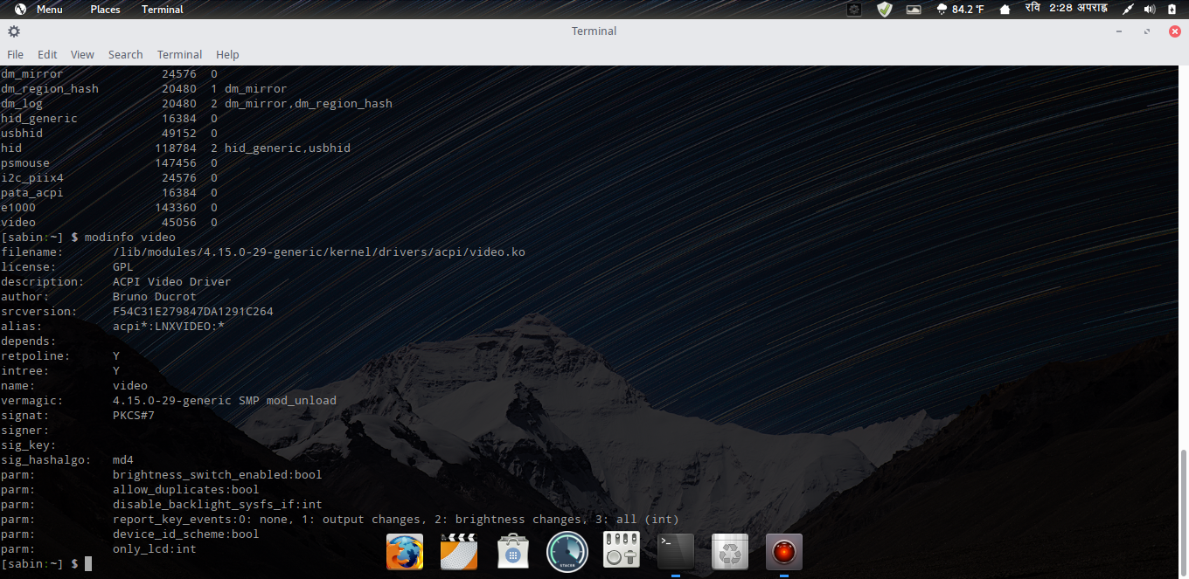Mention figure below reflects identification and location of video.

Figure : modinfo Video

## Description of setting up administrator and standard user

We can add different user’s account using GUI through user setting and also from CLI through terminal. As shown in figure 22 below, GUI was used to created administrator account named as ‘Sabin-Administrator’.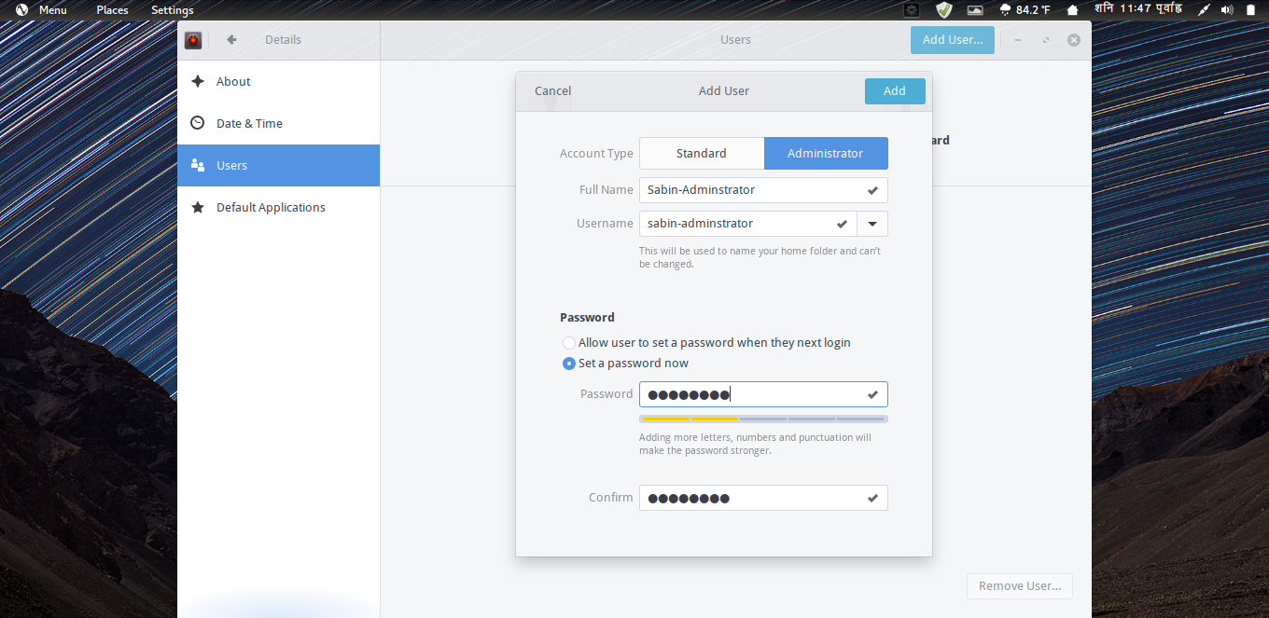

Figure : Administrator User

The other type account called standard account, we can add different user’s account using GUI through user setting and also from CLI through terminal. As shown in figure 23 below, GUI was used to created standard account named as Sabin-Standard. 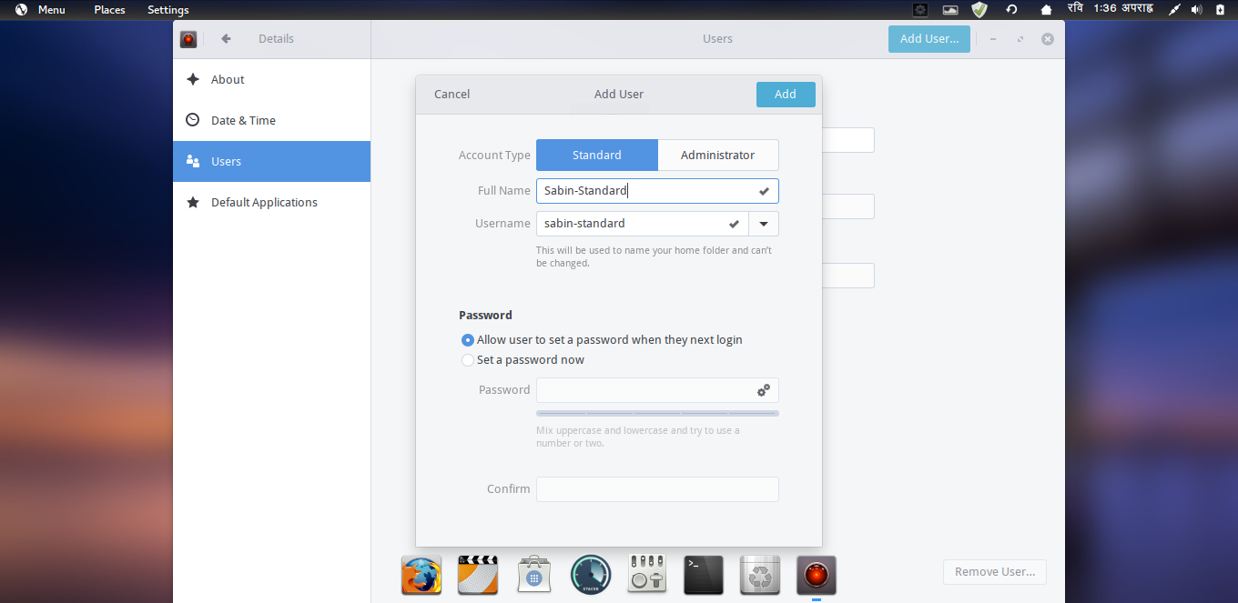

Figure : Standard Users

## Description of Network Set-Up

Network set up can be simply done using GUI on Linux. Firstly we need to go to network connection and then go to IPv4 to change address, gateway and netmask manually as shown in figure below.

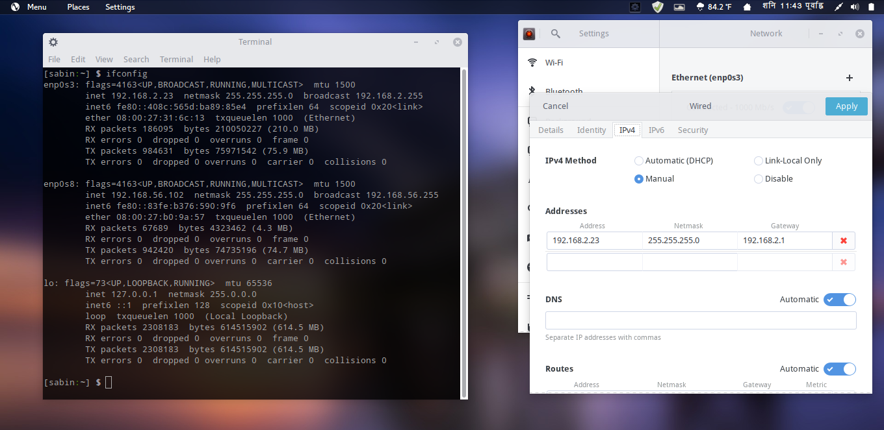

Figure : Network Set-up

## Identification and Installation process for one application

VLC is a both mobile and pc application software which plays most multimedia files like DVDs, Audio, VCD, and various streaming protocols. VLC can be set up using ‘sudo apt-get install vlc’ command from CLI. We were asked to type Password before installing VLC on the terminal.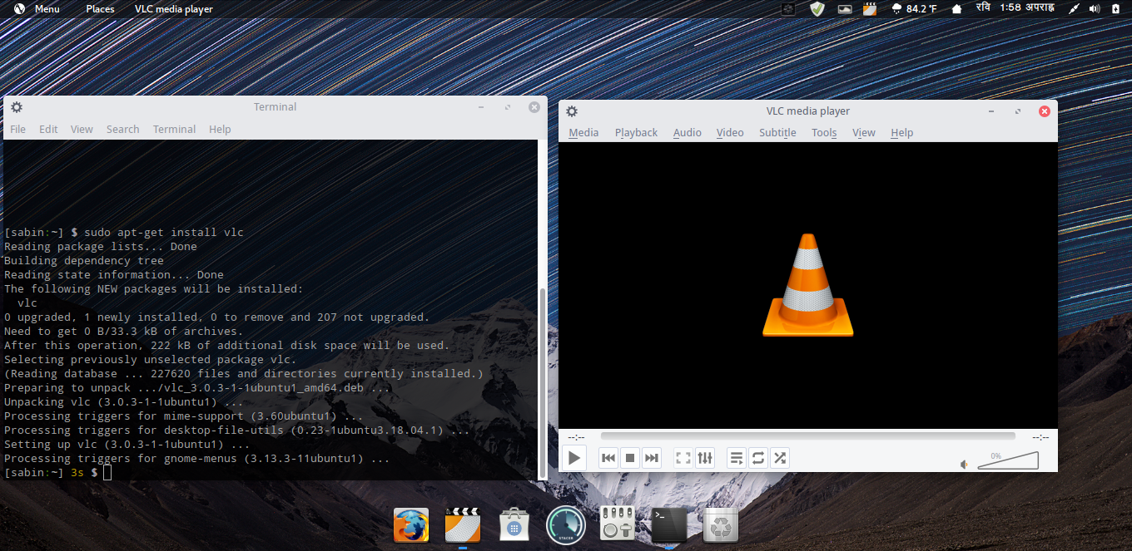

Figure : VLC Installed

# Testing of Linux System

## Identification of test plan for system

It is an important phase to test driver working operation after the installation of Pinguy Linux on

Virtual Machine. So, we can use the test plan system method for different fields to check drivers

On our system. Six important fields are mentioned below

## Record of how system performs against test plan

The important test plan system are mentioned below:

|  |  |
| --- | --- |
| 1. **Installation**  * Language and Locale * Monitor recognition | 1. **First Boot**  * Display Manager * Initial Boot |
| 1. **Networking**  * Windows Networking | 1. **Device and Peripherals**  * Removable Drivers (CD / DVD) * Sound and Video |
| 1. **System Application**  * File Manager Integration | 1. **System Administration**  * System tools |

Figure : Main Areas of Testing

|  |  |  |  |  |
| --- | --- | --- | --- | --- |
| **Test to perform** | **Expected results** | **Actual results** | **Explanation of results** | **Action if results do not match expectations** |
| **Language and locale** | Language and locale should be selected. | Language and locale were selected. | I was able to change the key map and language immediately during the installation process. | Result matched. No, any action. |
| **Monitor recognition** | Monitor should be recognized. | Monitor was recognized. | Monitor was able to display information processed by the computer’s video card after installation | Result matched. No, any action. |
| **Display Manager** | Display manager should show the user with a login screen. | Display manager showed the user with a login screen. | I was able to starts sessions when I successfully enter a valid username and password. | Result matched. No, any action. |
| **Initial boot** | Booting process should be done. | Booting process was done. | I was able to start initial boot, Pinguy Linux on the virtual machine | Result matched. No, any action. |
| **Windows Networking** | Computer system should access the internet | Internet connection was leaking. | I was able to install missing drivers on the system. | Result was not match so I check signal and router connection. |
| **Removable Drivers (CD/ DVD )** | Removable Drivers (CD/ DVD) should be detect. | Removable Drivers (CD/ DVD) was detected. | I was able to read the removable media play the file in it. | Result matched. No, any action. |
| **Sound and Video** | Sound and Video should be played. | Sound and Video playing was leaking | I was able to install Realtek drivers for sound and open source VAAPI drivers for video | Result were not match so I check  Driver through terminal. |
| **File manager Integration** | The document should be created, open and edited. | The document was created, open and edited. | I was able to check the extension like Jpeg, Html, Gif, .xlsx, .docx, Txt, BMP, MPEG, and Mp3. | Result matched. No, any action. |
| **System tools** | GUI tools should be work efficiently in disk partitioning | GUI tools was working efficiently in disk  partitioning | I was able to partition the disk using disk management tools which are preinstalled on OS. | Result matched. No, any action. |

Figure : Test Plan Performed

# Task 3

# Faulty PCs

Various computer hardware and software problems occur and need to identify or resolve them is called as faulty pc. Some of the faulty PCs issues as are listed below:

## The Screen is Blank:

* **Steps I followed to identify the fault:**

The computer was on but the screen is blank not showing any error messages.

* **Cause of the fault:**

Issue might occur with the connection between the computer and the monitor screen or monitor is damaged

* **Steps taken to remedy the fault:**

I checked monitor is plugged into a power point or not and also check the connection between the monitor and other hardware components, so I changed HDMI cable.

* **Success or Failure of the repair:**

After changing HDMI, the screen blank problem never occurred again.

## PC Overheating

* **Steps I followed to identify the fault:**

Using a different application, the whole system slows down and leads to frequent crashes due to overheating.

* **Cause of the fault:**

The main cause of PC overheating is either pc cooling system is not working properly or cooling system cannot handle the maximum capacity of the heating.

* **Steps taken to remedy the fault:**

I check pc fan and other heat generating components such as CPU and GPU. PC fan is not working properly so I cleaned it and run pc again.

* **Success or Failure of the repair:**

Then the problems was solved.

## PC crash before loading the OS

* **Steps I followed to identify the fault:**

When I start my pc, it was supposed to load the operating system but the PC only shows the manufacturer logo and then crash.

* **Cause of the fault:**

Cause maybe in a hardware component, either RAM is corrupted or hard disk is damaged and cannot load data inside it.

* **Steps taken to remedy the fault:**

There were multiple RAM slots, so I take out RAM one by one and start the pc but the issue continued, so I replaced a hard disk and load OS into it.

* **Success or Failure of the repair:**

After replacing a hard disk, the problem was solved.

## Wi-Fi not working

* **Steps I followed to identify the fault:**

I was unable use Wi-Fi on my pc. It had red symbol.

* **Cause of the fault:**

Wi-Fi driver was missing on my pc.

* **Steps taken to remedy the fault:**

I went to device manager and downloaded the Wi-Fi driver from official site.

* **Success or Failure of the repair:**

After I downloaded and installed Wi-Fi driver, the problem was solved.

## Hard drive missing

* **Steps I followed to identify the fault:**

When I tried to see all the hard disk partition I couldn’t find drive which I had partitioned.

* **Cause of the fault:**

The hard disk partition had somehow disappeared.

* **Steps taken to remedy the fault:**

To remedy the problem I had to use windows disk management software and I reformatted the partition**.**

* **Success or Failure of the repair:**

The problem was then solved.